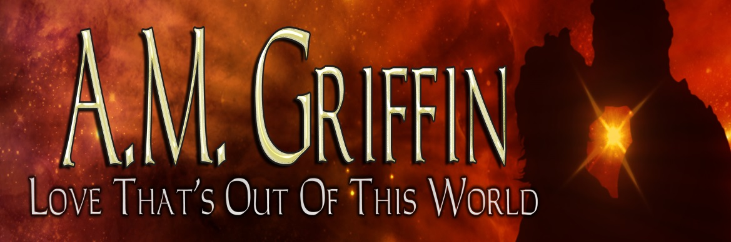 |  | - May 2014  - ne 2014
NEW ADVENTURES |  | In This Issue

Welcome to my first official newsletter! Woot! I so promise not to spam you with because believe me, I don’t have that much to talk about. You’ll only get information regarding new releases and major contest/giveaways.
Speaking of giveaways…I’m a book tour junky and I do giveaways all the time. Stay tuned for free swag and gift certificates.
WHAT I DO WRITE?
I began my writing career at Ellora’s Cave. In December 2012 I released my first book, Dangerously Mine, a science-fiction romance erotica. Dangerously Mine was subsequently followed by Dangerously Yours and Dangerously His, official making it a series, Loving Dangerously.
My erotica days are not over yet. The Loving Dangerously series is contracted for two more releases, Dangerously His and Dangerously Forever, which has both been submitted and anticipates a 2014 release.
I also write paranormal and Young Adult (I know, go figure). In August I will have my first paranormal release included in a multi-author box-set. Double Woot!
Dark Wolf Enterprises is the first book in a planned shifter series. I’ll have more to come about that novella and other books in the series in the upcoming newsletters.
My Young Adult series Cimmerian Moon will feature its first release, Against The Darkness on June 4th, 2014. This an entirely new venture for me and I’m excited to share it all with you, the readers.
WHY Science Fiction?
I love reading and watching science fiction. There are no rules and the possibilities are endless. My characters and worlds are subjected to my every whim. There’s absolutely nothing holding me back but my imagination. In Dangerously His, I pick up the series with Justin Blake, JB’s story.

I first introduced JB in Dangerously Yours, the second story of this series. In that story JB is the right hand man and best friend of Kane Epps and both of them, along with some other escaped humans slaves, have turned into space pirates. Yeah, space pirates-hot. After they were caught by the Galactic Counsel and forced to change their ways, the gang had to find other respectable jobs.

In Dangerously Hers, the third installment of the series, we follow Jessica or Jess, one of the ex-pirates, as she tries to start a new life on Sonis as a personal assistant to Rasha the Head Guard. JB plays a major role in this story because he’s the one person Jess has asked to come with her to help her get settled. While Jess is trying her best to acclimate to her new role and life, JB is not following any of the rules.

Stay away from the human females.

In Dangerously His JB’s inability to follow the rules has worn out his welcome on Sonis and has displeased the one person who he should never get on his bad side… Taio Xochis.

Dangerously His: Blurb
Justin “JB” Blake has never met a woman he couldn’t bed—or one he wants to keep. That changes the second he lays eyes on Princess Saia Xochis. The beautiful alien makes his body burn and his heart ache. She will be his. All JB has to do is risk life and limb at the hands of her abusive father, her protective brother, and her warmongering intended mate.
The possibilities of death and dismemberment have never stopped him before.
Inside Scoop: This book has a small taste of female/female fun—as well as scenes of abuse that are decidedly not fun.
Dangerously His: Excerpt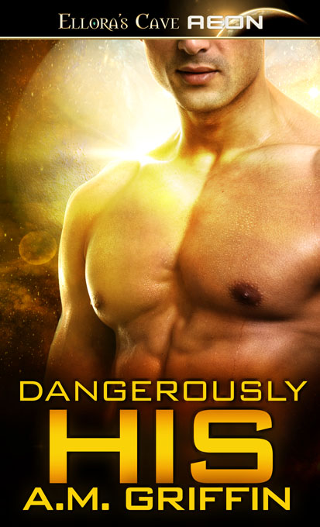
KINDLE ELLORA’S CAVE
What’s in the next Issues:
- Against The Darkness
- Brought To His Knees (Multi-author box-set). “Like” our FB page.
Other ways to keep in touch with me:
- Website
- Subscribe to my Amazon Page
- “Like” me on FaceBook
- Follow me on Twitter
- My Goodreads page
- Join my Street Team
- I LOVE hearing from my readers! amgriffinbooks@gmail.com

EXTRAS:
UPCOMING TOURS with GIVEAWAYS:
Book Monster tour starting June 16th

Join the ARC review list

Books By A.M. Griffin

Cimmerian Moon Series:

Against The Darkness, book #1: Releasing June 4th, 2014
Excerpt
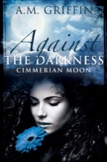

The Ashes That Remain, book #2: Available August, 2014
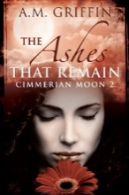

In Danger’s Embrace, book #3: Available October, 2014

Brought To His Knees: 11 Author Box-Set: Releasing August 19th, 2014
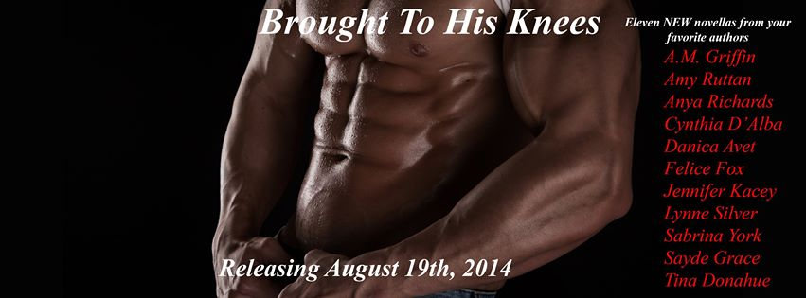
Official cover coming soon!
Website

Loving Dangerously Series:

Dangerously Mine, book #1: Available now
Excerpt
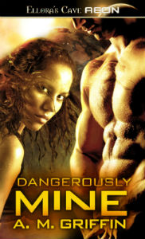
Buy Link: http://ow.ly/wt09J
Available on Audible

Dangerously Yours, book #2: Available now
Excerpt
Buy Link: http://ow.ly/wt0gw
Available on Audible

Dangerously Hers, book #3: Available now
Excerpt
Buy Link: http://ow.ly/wt0im
Available on Audible

A. M. Griffin Bio:

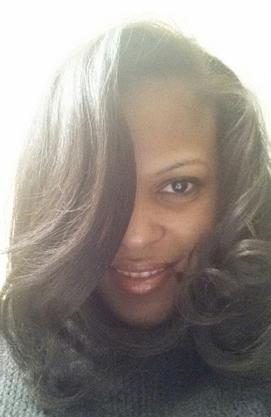

By day I see myself as Clark Kent – or maybe a girl version of him. I’m working hard at the day job, trying not to blow my cover. Then, in the face of danger – or in my case, at night, I’m a super-hero.
In my head, I’m fighting crime wearing a black-leather cat-suit. Of course I have the body to make my outfit work. I’m wearing a black mask, with my glossy (and split-end free) black hair hanging down my back. To top this uber cool (and slimming) ensemble off, I’m wearing fire engine red lipstick over full, pouty lips. On my skinny sexy legs, I have on stiletto boots that ride up to my knees.
Now I’m ready to fight crime – cool like (wha-cha).
Oh wait, I let my imagination run away from me. I don’t fight crime, I spin tales in my pajamas. Which, to keep the flow on the cool side, could be imagined not as flannel with snowflakes pictured on them, but as black silk.
So with my black silk pajamas on, after putting in hard hours at the day job, at night I sit at my computer looking cool as hell and spin tales of alien invasions, sexy alien kings, tough-as-nails Earth women, fighting, murder and of course, alien dismemberment.

